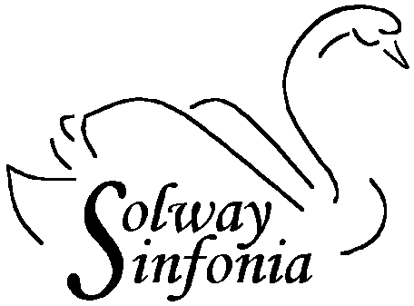
Dear Parent/Carer
Would your child/children like to come and join us in our Young Musicians’ Day 2019?
On Sunday 1st September the Orchestra opens its doors and invites budding young orchestral musicians to join with our players to make music for the day. Players of all orchestral instruments are invited (Grade 3 standard or above). We will send you a copy of the music for you to practise beforehand. There is no charge for participation in this event.
The session will take place from 10 to 5pm in Dumfries Academy Hall. During the rehearsal, refreshments and snacks will be provided and the day rounded off with a short informal concert for friends and family (friends and family are also most welcome to stay for all or part of the rehearsal).
Music will be issued in advance by email to enable players to practise their music beforehand. Please indicate on the application form if you would like the music to be sent to you by post instead.
Please read the following and tick one of the boxes.
I agree to points 1 to 4 below

I do not agree to points 1 to 4 below

1. the Solway Sinfonia may take photographs of the rehearsal and concert.
2. the Solway Sinfonia may use any such photographs on the orchestra website http://solwaysinfonia.org.uk
3. the photographs can be shared with the Holywood Trust who are sponsors of this event.
4. the Holywood Trust may use the photographs in publicity, in promotional materials and on their website.
The Solway Sinfonia gratefully acknowledges the financial support it is receiving from the Holywood Trust www.holywood-trust.org.uk to enable it to put on this event.
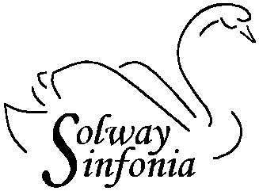

Please complete the following information and submit (see bottom of page).
The closing date for applications is Friday June 7th 2019
I give permission for my son/daughter to take part in this activity
Signature of Parent/Guardian…………………………………… Date…………………
Name of player………………………………… School…………………………………………
Instrument……………………… Grade/years of study……………………………….
CONTACT DETAILS
Name……………………………….
Home address……………………………………………………..…………………..……………
Postcode…………………
Email address………………………………………………………………………
Home Tel………………………………….
Mobile Tel…………………………………………………
Emergency Contact (person)……………………………………….
Emergency contact tel. number………………………………….
Please submit your application to either
- Mr N Riley at the Music Department, Wallace Hall Academy, Thornhill, DG3 5DS
- Your teacher, who will forward it to N Riley
- Solway Sinfonia directly (contact@solwaysinfonia.org.uk)
We will confirm receipt of your application.
Please tick the box if you would prefer your music to be sent to you by post instead.

Please note that
- participation in this event is open to all pupils in D&G and beyond
- it is not necessary to have music lessons in school to take part
- you are entitled to refuse to allow any photograph of your child to be used,
but you must say so on the form

